Unit 9 Aggregate Functions

Corey Crooks
Purdue University Global
IT163 – Kathi Nicholson
April 28, 2021

Using built-in and aggregate functions, show the total quantity of sales by month
SELECT MonthName(Month([SaleDate])) AS [Month], tblSales.SaleDate, tblSalesLineItems.Quantity
FROM tblSales INNER JOIN tblSalesLineItems ON tblSales.InvoiceNumber = tblSalesLineItems.InvoiceNumber;
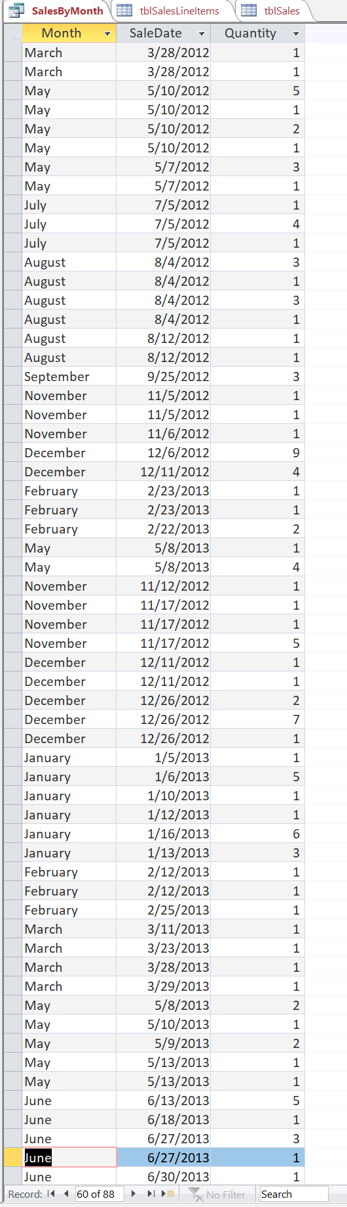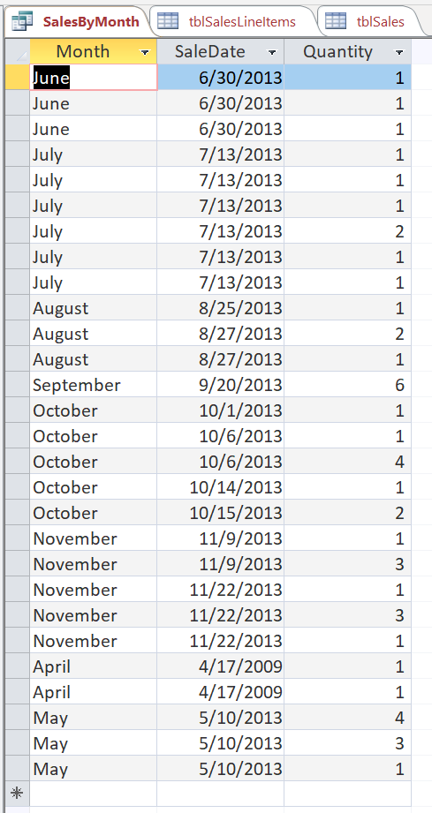
2nd
1st
Incorporate a calculation within a field in a query that will reflect a 10% reduction in retail price for all Products from the Products table.
SELECT tblProducts.Description, ([RetailPrice]*0.9) AS SalePrice, tblProducts.RetailPrice AS OrigPrice
FROM tblProducts;
2nd
1st
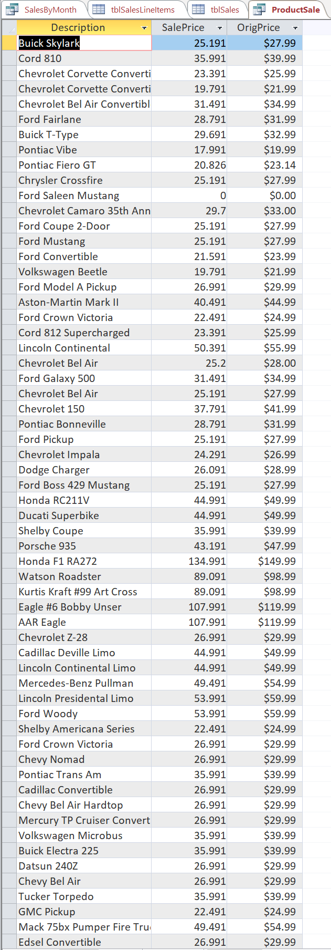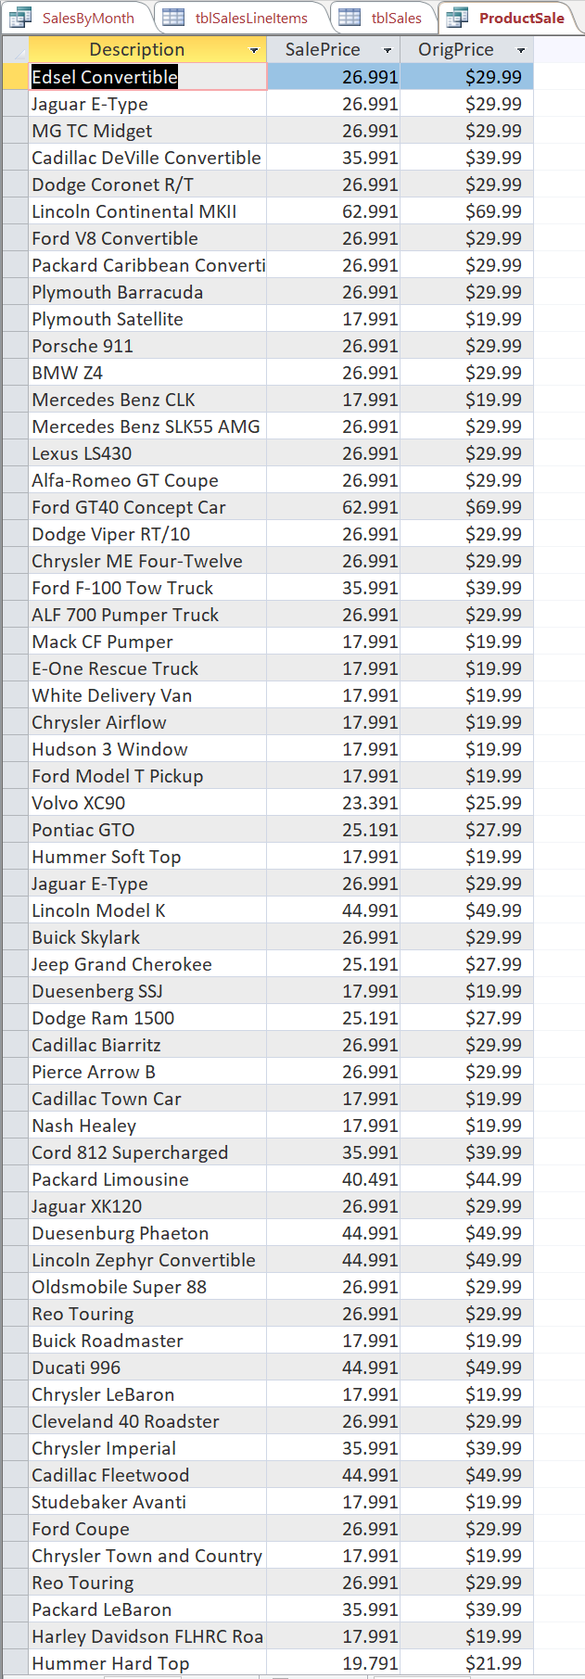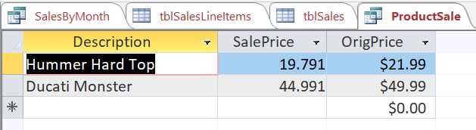
3rd
Sometimes we want to allow the user to interact with the query rather than using fixed values in the where clause. We can do this with a parameter query.
SELECT tblCustomers.Company, tblCustomers.State
FROM tblCustomers
WHERE tblCustomers.State = [Only Show Which State?];
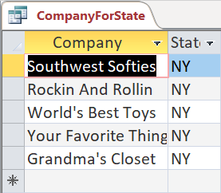
Input = ‘NY’
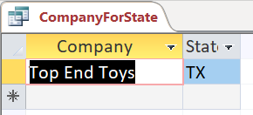
Input = ‘TX’

Let’s look at an action query this time. One of the customers has a misspelling in their company name and we want to correct the data in the table.
UPDATE tblCustomers SET tblCustomers.Company = 'Terrific Toys'
WHERE tblCustomers.Company = 'Terriffic Toys';
